* **WHAT IS A GIT?**
* Distributed version control
* Collaborates developers
* Tracks change(commit history)
* Local and remote repository
* **HOW TO PUSH A FILE INTO YOUR GITHUB ACCOUNT?**
* **If you own/creating a repository**
* Create a local directory (mkdir directory_name)
* Cd to that directory
* Create a file (for eg. demo)
* Initialise the directory (git init)
* Add the file to commit (git add demo.txt)
* Commit the file (git commit –m “the message”)
* Link your github account ( git config –global user.username rhegisan
* Create a new remote repostitory in your github account and link it to the local repositiory ( git remote add origin link_of_your_remote_repository
* Now push your file (git push origin master)

**OR**

* **If you have to work on existing repository**
* Clone the repository in your local machine( git clone Liink_of_repo)
* Add the file to commit
* Commit the file
* Push the file( git push)
* **Workflow**
* 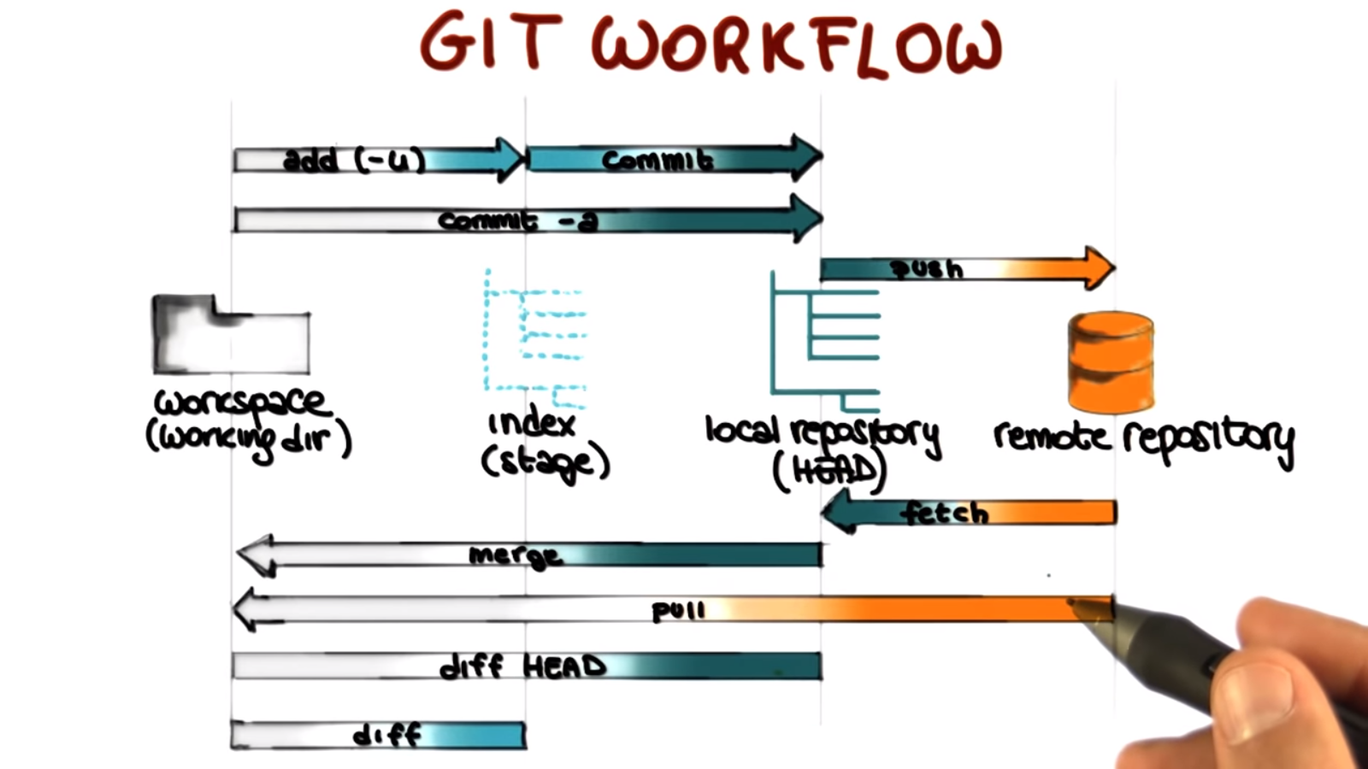
* **WHY STAGING AREA?**
* It allows us to select only that which we need.
* Commit only 1 topic at one time else other developers will be confused.

**How to undo changes?**

https://www.earthdatascience.org/workshops/intro-version-control-git/undoing-things/#:~:text=If%20you%20have%20modified%2C%20added,the%20modifications%20will%20be%20unstaged.&text=Notice%20that%20now%20your%20file%20is%20no%20longer%20being%20tracked!

